THE MOST POPULAR QUESTIONS ABOUT LIGHTROOM PRESETS.

Q: How to install presets to Lightroom?
A: You should make the following steps:
- Turn off the Lightroom
- Unzip the presets you downloaded to somewhere on your computer you can find
- Windows user: C:\Users\ <username>\AppData\Roaming\Adobe\Lightroom\Develop Presets
- Mac OS user: <your home folder>/Library/Application Support/Adobe/Lightroom/Develop Presets
- Create folder with preferred name
- Copy to these folder downloaded presets

Can’t find it? Open the LR preferences, head to “Presets”, and click on the “Show Lightroom Presets Folder” button.

Alternative way
Double click on preset file, and it will appear in User Presets folder in Lightroom.
Or
Open Lightroom, go to develop mode, right click on presets folder and select import presets.
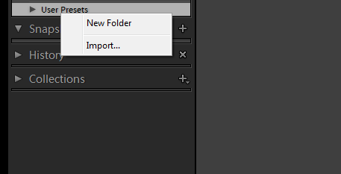

Q: How to remove orange\red\yellow skintones?
A: It’s pretty easy, just make the following steps:

- Apply the preset you want
- Go to HSL panel > Saturation
- Click on little circle button named “Adjust saturation by dragging in the photo” *red arrow
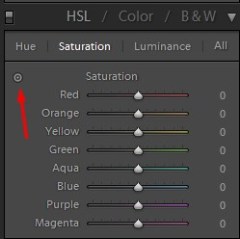
- Move your mouse to the skin, press the left click button and drag, down to reduce saturation, up to increase
Q: I have just apply the preset, and the image become to cold, what I have to do?
A: When you use preset or action, and the image is very cold or very warm, just change a temperature (White Balance) of this image.


This FAQ will be updated, just ask me a question and i will answer.

